Deploying 2 tier app on ECS

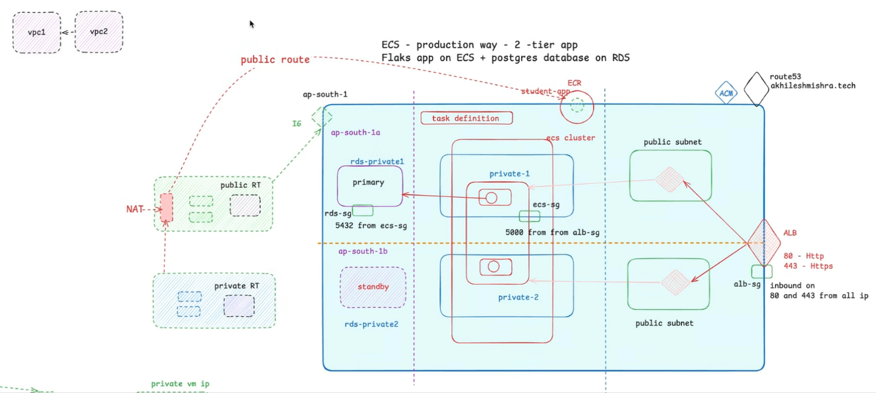
Step 1 – Creating custom VPC and subnets
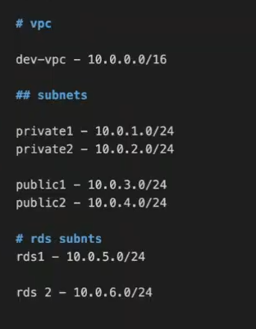
We will have 6 subnets as evident from the diagram, 2 private subnets which contain ECS services, and 2 private subnets which are for databases. The other two being public
- 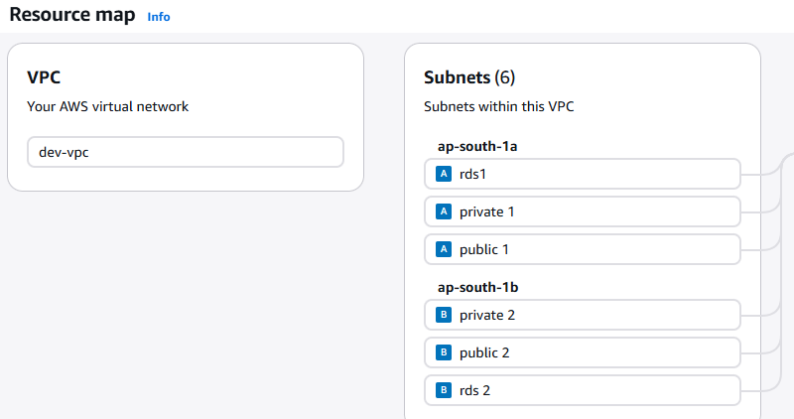
Then create route tables, by default there is a route table which defines local route such that each resource in a VPC can communicate with each other
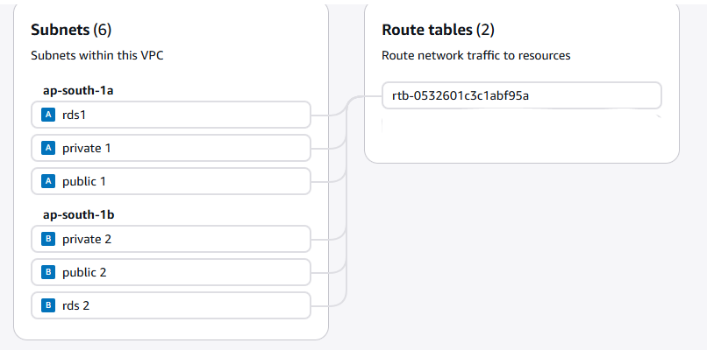

-then , add a route in pub rt which will allow anything coming from the internet to attach to Internet Gateway – for comm to outside world.
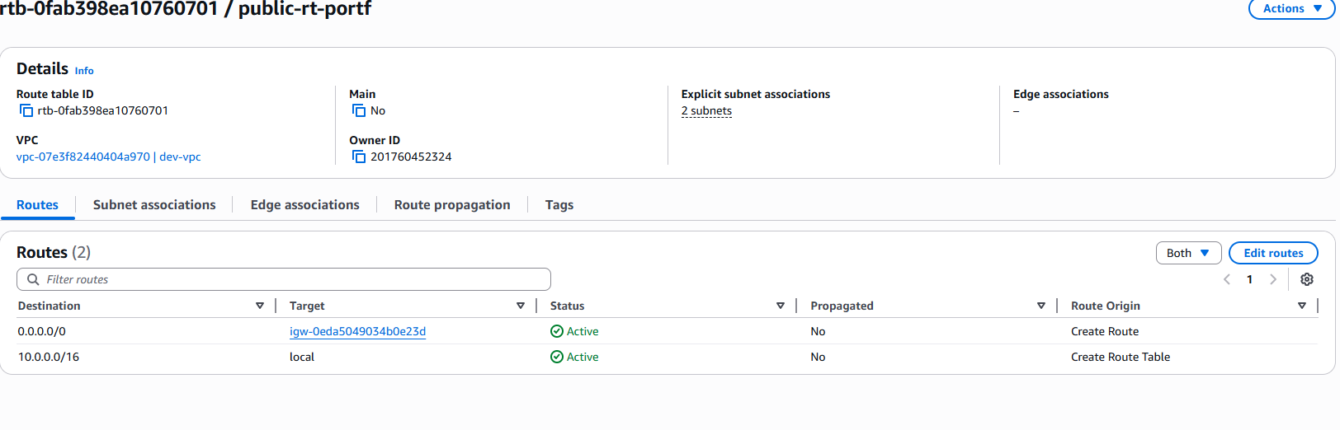

Now go for creating Security groups, we need three of them, one attached to ALB, one to ECS and one to RDS.

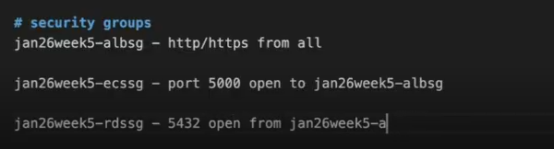

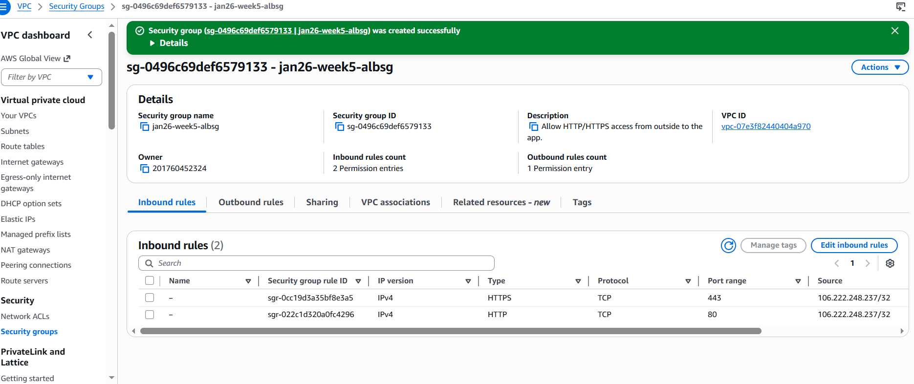

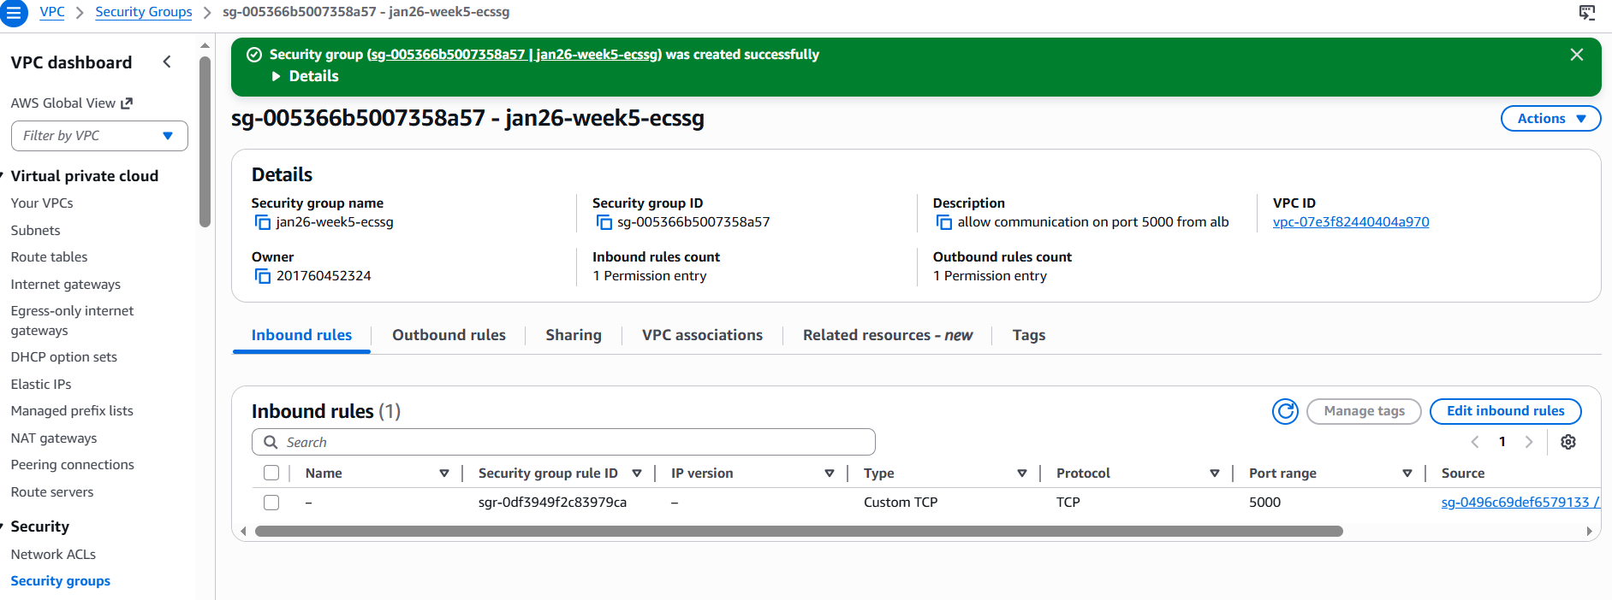

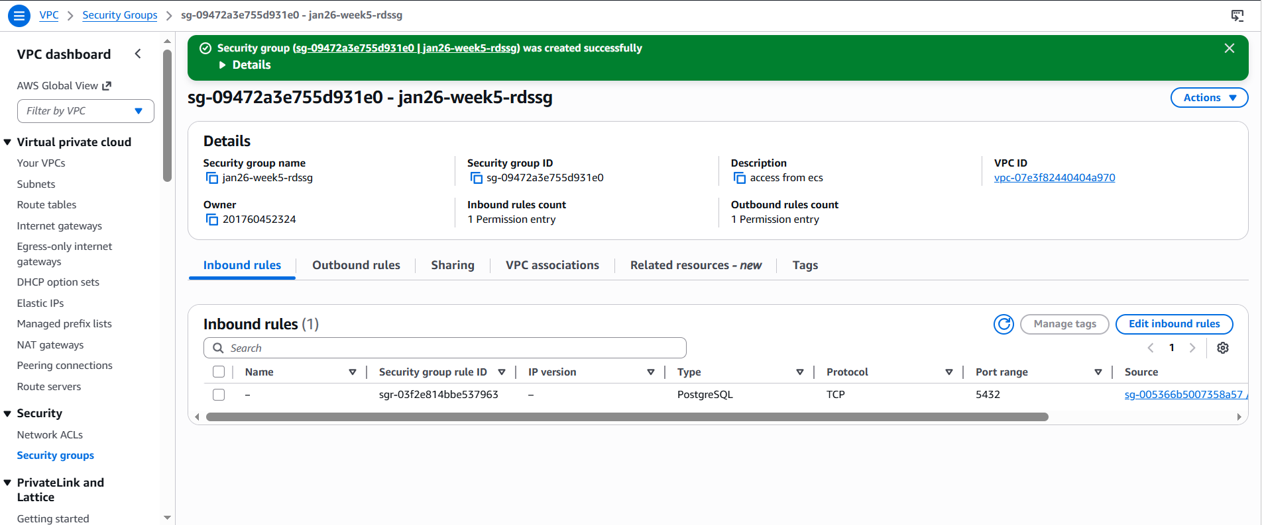

After adding the required inbound rules and creating the security group head to the RDS instance creation, i.e. create database
First we create subnet groups, which will contain the rds private subnets we created before, and we will choose this group while creating the RDS instance, if I don’t create subnet group, aws creates a subnet group by default which will contain all the priv + public subnets in the group which is not secure, because RDS has to be in a priv subnet.

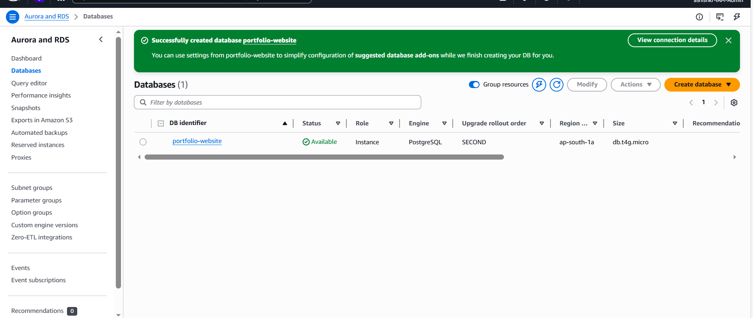

(Read about RDS proxy)

Next we will be saving DB credentials (env variables) in Secrets Manager:

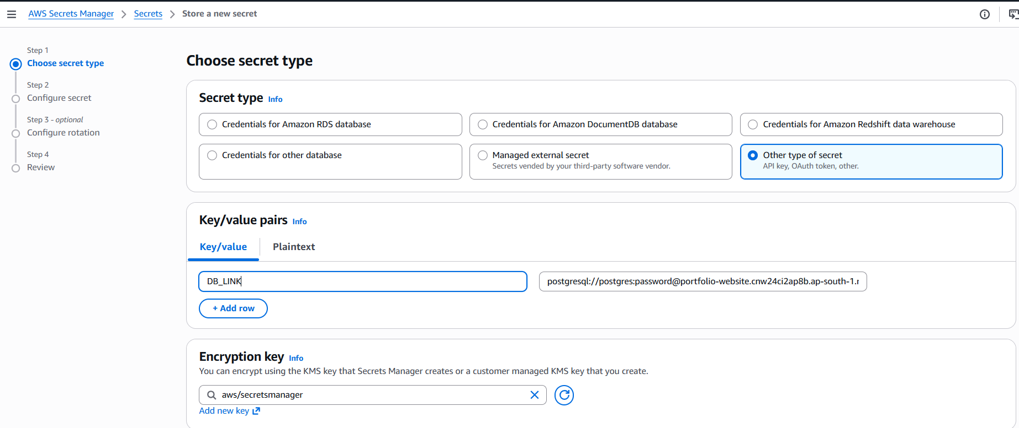

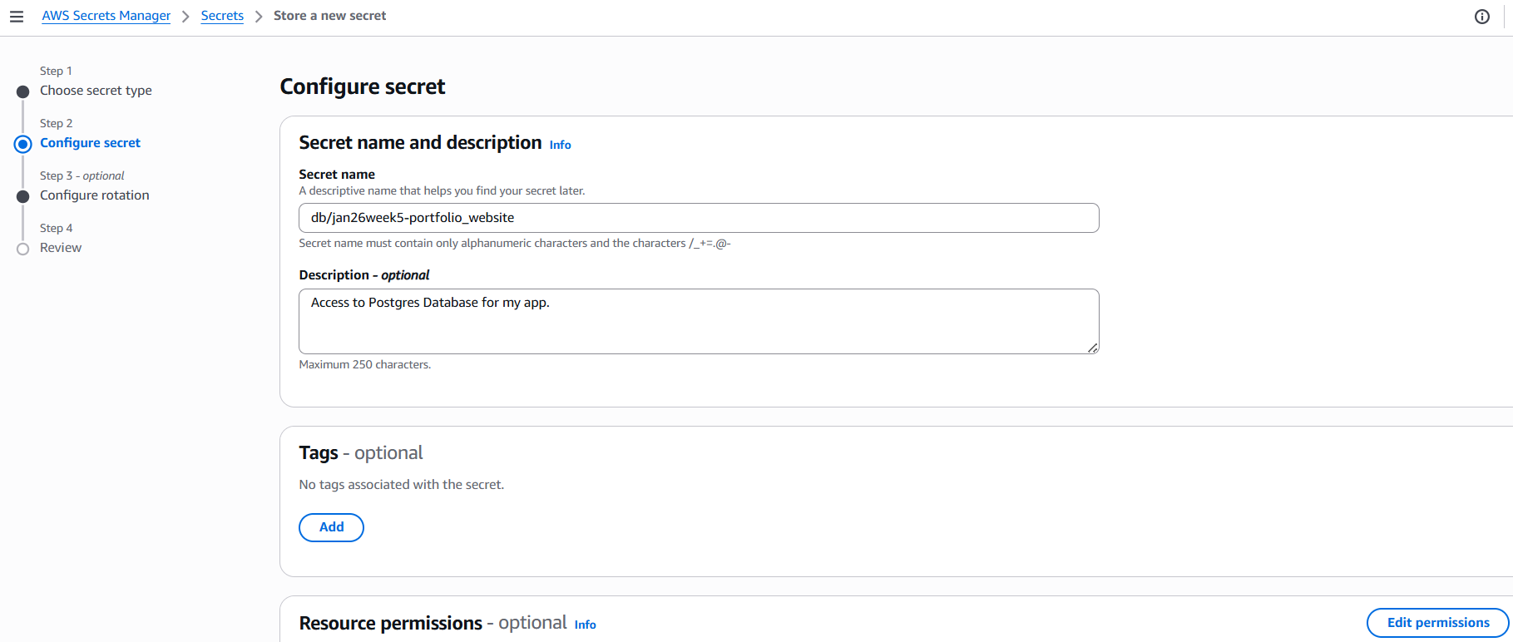

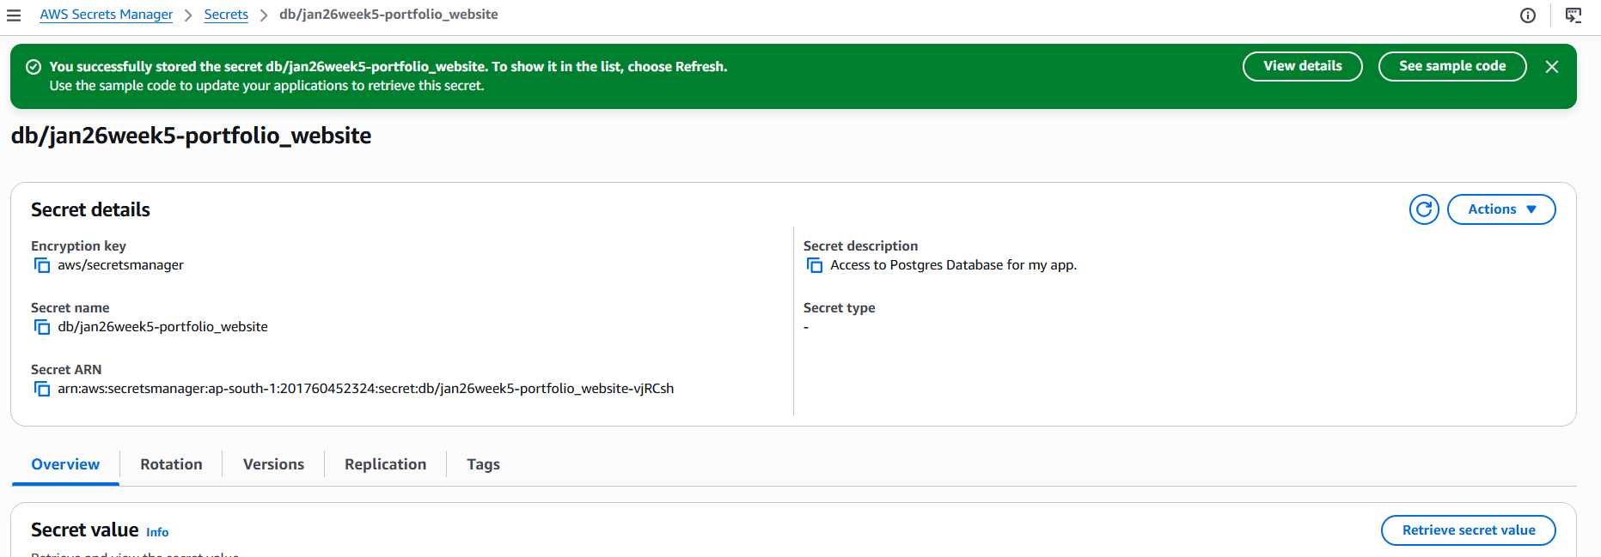

After this, start creating the ECR repo where I will push the custom image.

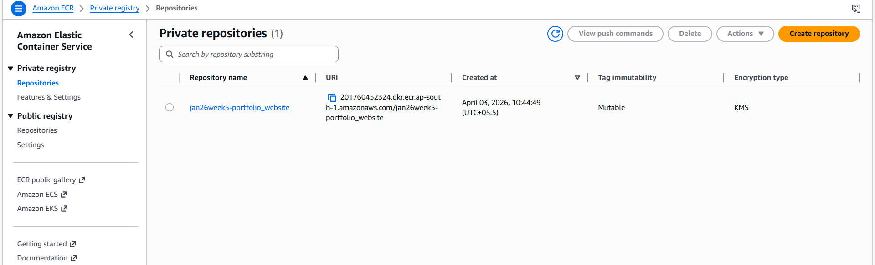

Private repo created, now I will do the steps to push image to this repo:
- Create the image from Docker file – I ran docker build -t myapp . (my app being image name)
- Next, Authenticate docker on my local machine to ECR
  - I have to first retrieve an authentication token to allow Docker to communicate with your private registry. This token is valid for 12 hours. I ran the command aws ecr get-login-password --region <your-region> | docker login --username AWS --password-stdin <aws_account_id>.dkr.ecr.<your-region>.amazonaws.com

- Tag the local image (myapp) with the full ECR repository URI. URI format is: <aws_account_id>.dkr.ecr.<region>.amazonaws.com/<repo-name>:<tag>
  - Command - docker tag <local-image-name>:latest <aws_account_id>.dkr.ecr.<your-region>.amazonaws.com/<repo-name>:latest

- Push the image – docker push <tagged image name>
  - I will run docker push <aws_account_id>.dkr.ecr.<your-region>.amazonaws.com/<repo-name>:latest

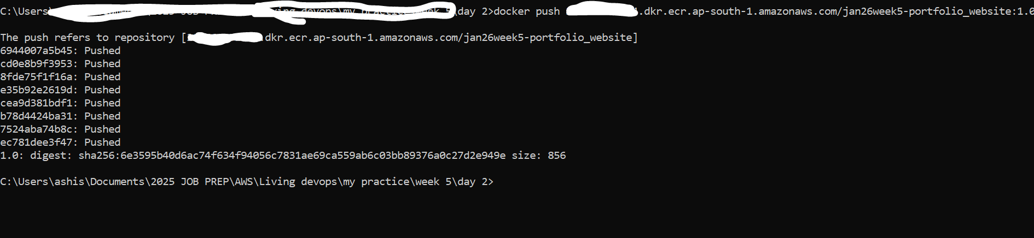

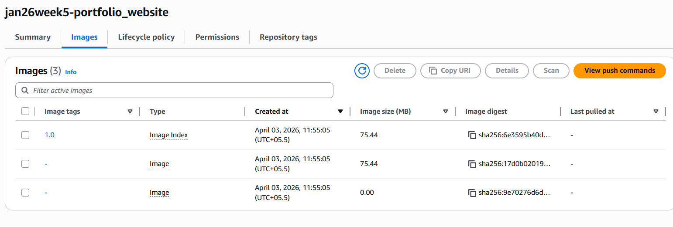

Next go to ECS and create task definitions, tasks, services
- Create ECS cluster \
- Create task definition
  - While giving container details in creating task definitions, in the Image URI – paste the ECR repo URI but don’t forget to mention the tag (1.0/2.0 etc.), it will not work otherwise(except when the tag is latest)
  - In real world, tags are mentioned as commit IDs

In the env variables, select Value From and copy the ARN of the secrets you created. But for this, ECS needs to have task role which enables it to communicate with Secrets Manager.

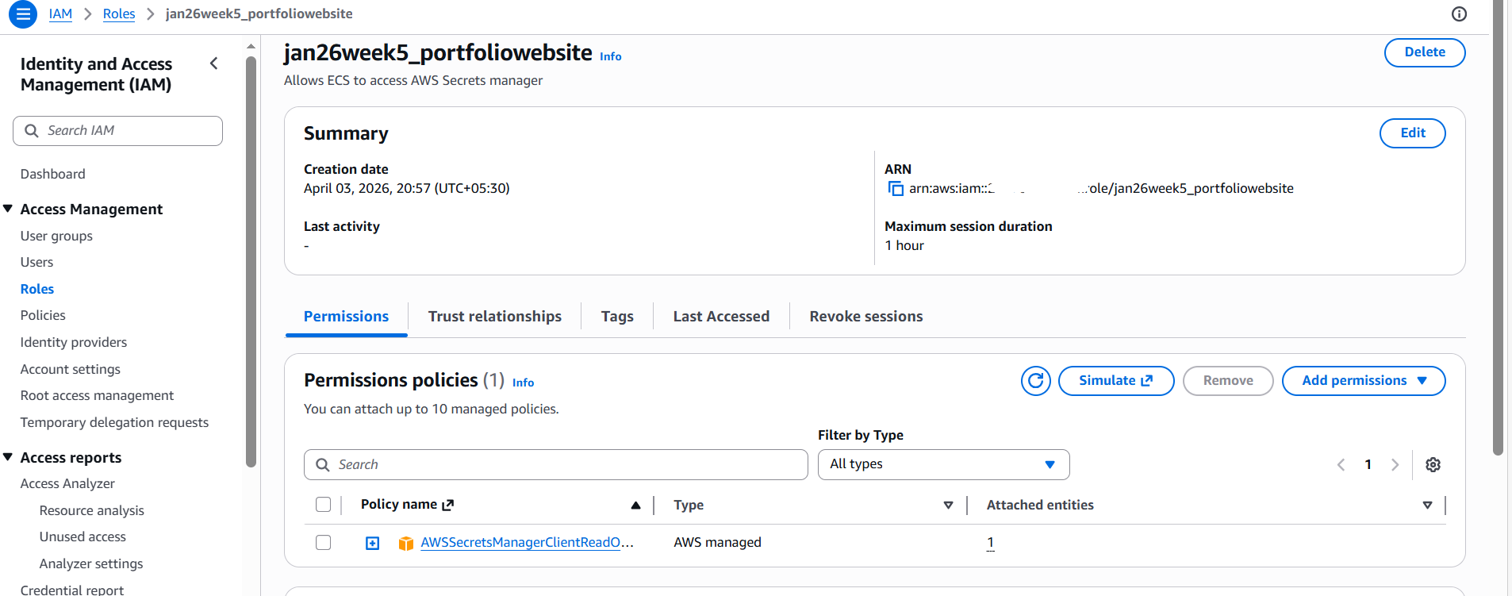

Then attach this role to ECS task defn --- create a new revision of the task definition to do that.

After that go to cluster tab and create service, while creating service, also select load balancer and configure an ALB.

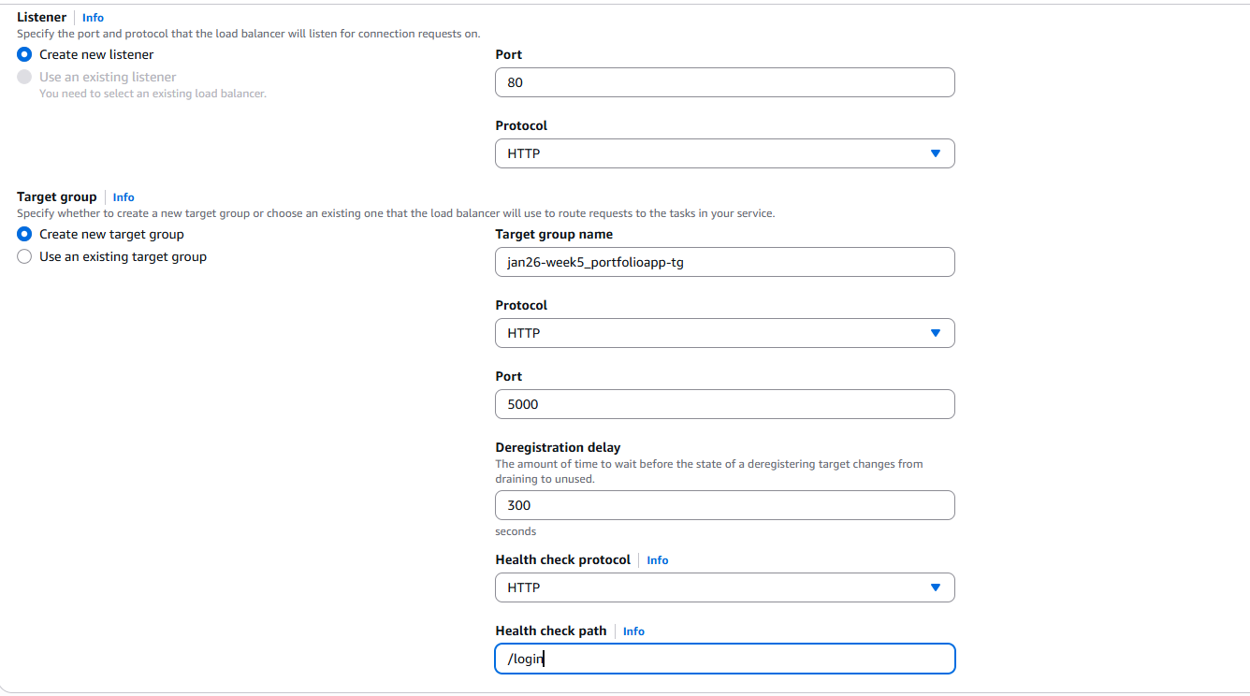

After creating service, the tasks started coming up, I waited for few minutes for it to come up, but, it failed. I looked at the error it said:
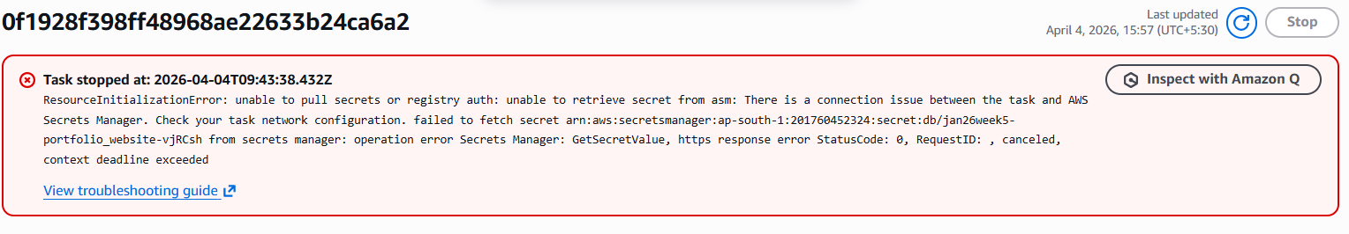
This means, the ECS is not able to fetch environments variables from the secrets in secrets manager, there are two reasons for this – one is – the task execution role, I added a GetSecretValue and DescribeSecret Allow permissions to retrieve the secret.
Second reasons is, • Since ECS is in a priv subnet, the tasks running in it has to fetch env variables / DB credentials / configured in AWS Secrets Mgr which is a public AWS service. Due to being in priv subnet — it doesn’t have a route direct to that public service. (same is also the case of fetching the image from ECR because ECR is also another public service outside the logical scope of a VPC.). Hence I need a outbound only internet connection from the private subnet which hosts ECS tasks, I used Nat GW for this purpose.

After I added the NatGW, and again ran the tasks it gave me a different error :
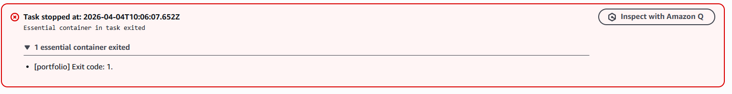
I checked the CLoudwatch logs – and the error was “sqlalchemy.exc.ArgumentError: Could not parse SQLAlchemy URL from given URL string”

I found out that the issue is in my key and value of fetching env variables from secrets manager. I had chosen the value as “value from” and pasted the secret ARN I created earlier. When I looked at the JSON format of the task definitions, and checked the secrets variable :
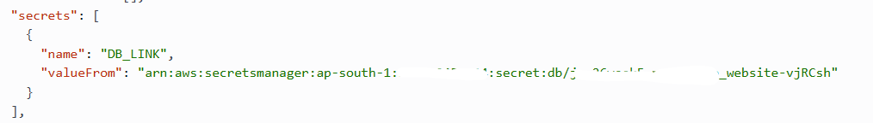
I found out that, there is a missing double colons :: at the end of valueFrom field. Due to the missing ::, AWS sends the entire JSON object to my container. The Python code then sees DB_LINK as a string that looks like {"password":"...", "host":"..."}. SQLAlchemy tries to parse that curly-bracket string as a URL and fails with the ArgumentError.
Apart from this, I also learnt that the generic format for the valueFrom field in the arn format is this: arn:aws:secretsmanager:region:aws-account-id:secret:secret-name:json-key:version-stage:version-id
Here I am keeping version-stage and version-id as blank, use whichever is the latest version. I looked at my existing valueFrom string and saw that I have not appended the key_name also in the end. The key name is what I have kept while creating the secret in the Secrets Manager, In my case key_name is DB_LINK. So I changed the valueFrom :
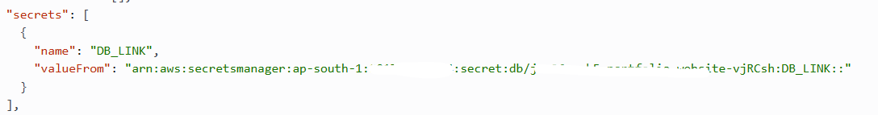

I again ran the service by going into the cluster, and finally the task run was successful as the logs also showed
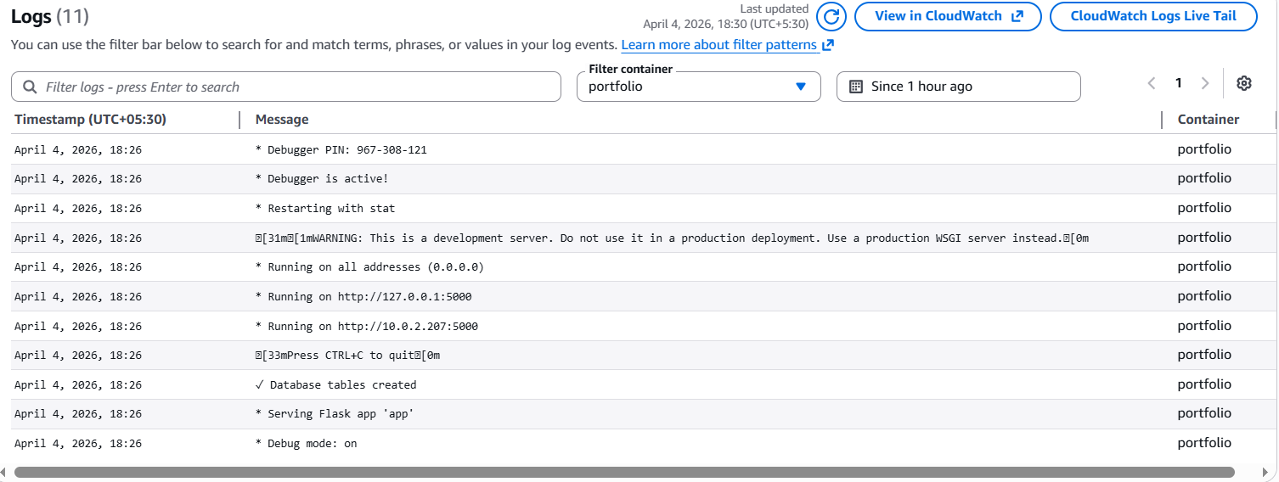

However, I later saw that ELB health checks failed error came up, this was because I mentioned an incoreect health check target path in the target group. I later changed it to (‘/’) i.e. root, and then the targets came healthy.

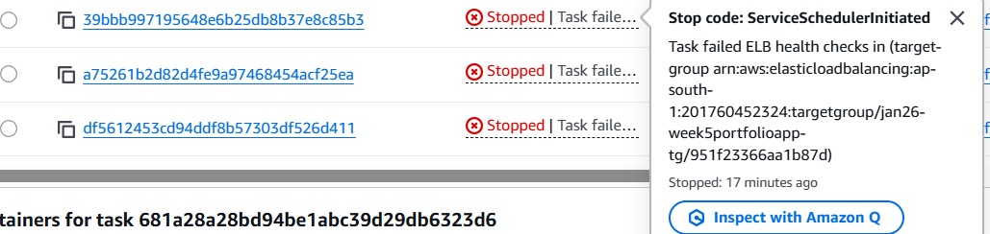

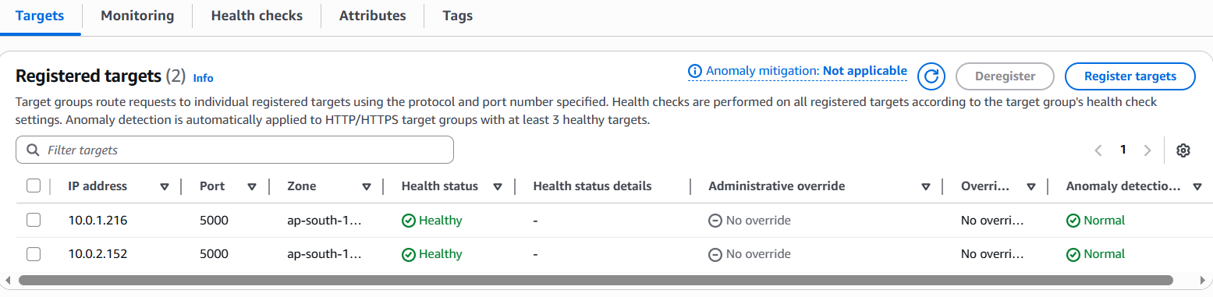

Finally I opened the ALB DNS name in the new tab and it opened the new website.
